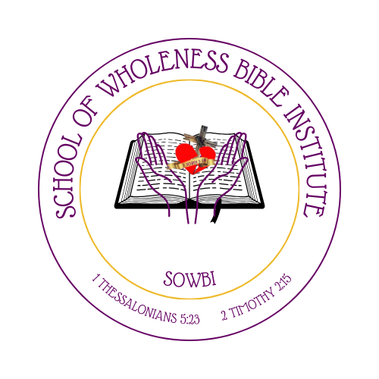

SCHOOL OF WHOLENESS BIBLE INSTITUTE
APPLICATION PACKET

(I Thessalonians 5:23 & 2 Timothy 2:15)



LOVE -N- ACTION GLOBAL MINISTRIES, INC
11596 Hastings Bridge Rd Lovejoy, GA 30250
Office (470) 919-6682 Cf# (857) 419-4300 Email: lovenactioncoc@gmail.com
Facebook: lovenactioncoc
Instagram: lovenactioncoc
Website: lovenactioncoc.org

DO YOU HAVE A DESIRE TO GAIN SPIRITUAL KNOWLEDGE AND RIGHTLY DIVIDE GOD’S WORD WITH SIMPLICITY AND CLARITY?
If your answer is YES, then make plans to attend the School of Wholeness Bible Institute every Tuesday night from 6:30 to 8:30 p.m.
The School of Wholeness Bible Institute is a nonprofit, tuition-free course and accredited college-level class that provides foundational studies and training for committed, consistent, motivation, determined, Believers, Ministers, Laymen, Gentiles.
Course Highlights:
- Laymen: Enhance your knowledge and understanding of God’s Word.
- Leaders: Learn to organize and govern God’s house more effectively.
- Ministers/Shepherds: Improve your teaching and homiletic skills (preaching and writing sermons using the 5 W’s).
- Gentiles: Be introduced to the Bible, Christianity, other religious beliefs, and Jesus’ superiority over all things.
About the Program:
The School of Wholeness Bible Institute is an eight-month, college-level theology class held every Tuesday from 6:30 p.m. to 8:30 p.m.
- First Class: Tuesday, March 4th, 2025.
- Registration forms will be available on social media, website and at our location building in Lovejoy, GA.
- Students will receive their class schedule and course outlines at the beginning of the program.
Meet Our Instructors and Special Guests:
- Gabriel Dolce (Pastor/Instructor)
  - Phone: (678) 683-1887
  - Email: gdolce3101@aol.com
- Eva Hill (Pastor & Instructor)
  - Phone: (478) 230-8419
  - Email: lovenactioncoc@gmail.com
- Special Guest Instructors (to be announced).
Our Mission:
The mission of the School of Wholeness Bible Institute is to teach and train the true, inspiring Word of God, equipping believers to refute false doctrines, boldly confess their faith, and empower others for the Great Commission before the return of our Lord and Savior, Jesus Christ (Ephesians 5:11-12).
Join us as we grow together in faith, knowledge, and understanding!

Welcome to the School of Wholeness Bible Institute
Dear Student,
Thank you for your interest in the School of Wholeness Bible Institute (SOWBI), a biblical education institution dedicated to equipping students with training and resources that can make a profound impact on the world. Regardless of your career goals, the time you spend at the School of Wholeness Bible Institute will prepare you to face life’s challenges as an effective servant and minister of our Lord Jesus Christ. Our focus is on preparing you not just for a career, but for life itself.
This package contains the materials you need to complete your application and gain acceptance for study at the School of Wholeness Bible Institute. Please review the materials thoroughly and follow the instructions provided. Should you require any additional information, feel free to contact us using the details provided above.
Application Checklist:
- Application: Please complete and sign the enclosed application form. Ensure all fields are filled out. If you plan to take a class rather than the full course, please let us know.
- Photograph: Include a wallet-sized photograph of yourself with your application.
- Recommendation Letter: A recommendation letter from your spiritual leader is required. This letter must be emailed directly to the school.
- Transcripts: Students planning to enter the school directly from a previous institution with college credit must submit official transcripts. A transcript request form is included in this package.
- Deadlines: The application deadline for this course is February 23rd, 2025. All completed application materials must be submitted to the school by this date.
Important Information:
To all our students, we are deeply honored that you have chosen the School of Wholeness Bible Institute to further your spiritual knowledge and understanding of God’s Word. Welcome!
Reminder: The first day of school courses/classes is scheduled for Tuesday, March 4th, 2025, at 6:30 PM.
For more information, please contact Pastor Gabe.
Additionally, please submit a written essay explaining your purpose for taking this class.
We look forward to embarking on this spiritual journey with you!
His Servant,
Eva Hill
School of Wholeness Bible Institute Pastor/Instructor

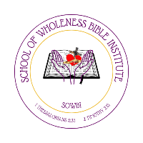
STUDENT REGISTRATION
SCHOOL OF WHOLENESS BIBLE INSTITUTE
LOVE -N- ACTION GLOBAL MINISTRIES, INC.
11596 Hastings Bridge Rd Lovejoy, GA 30250
Office (470) 919-6682 Conference (857) 419-4300
Email lovenactioncoc@gmail.com

Title: Mr. Mrs. Ms. Ministerial Position. ______________ Other______________________
Last Name__________________ First Name _______________Middle__________________
Address ___________________________________________________________________
City _______________________________State_________________ Zip Code___________
Cell ____________________________Email______________________________________
Have you been Saved? ______________How Long? _______________________________
Church Attending/serving: _____________________________________________________
__________________________________________________________________________
Tell us about your Ministerial Position (Servant hood) ________________________________
________________________________________________________
Briefly describe your journey of faith and your desire to attend SOWBI:

Program Expectations
Are you committed to attending classes every Tuesday from 6:30 PM to 8:30 PM for the duration of the 8-month program?
  - Yes / No (circle one)
Do you have access to the required resources (Bible, notepad, and other study materials)?
  - Yes / No (circle one)
Are you willing to complete assignments, participate in discussions, and contribute to a collaborative learning environment?
  - Yes / No (circle one)

Additional Information
How did you hear about SOWBI?
  - Social media / Church Announcement / Referral / Other (circle one)
If other, please specify: ________________________
Do you have any special needs or accommodation?
  - Yes / No (circle one)
If yes, please explain:

Agreement and Signature
By signing below, I acknowledge that the information provided in this application is true and complete to the best of my knowledge. I understand that acceptance into the School of Wholeness Bible Institute is subject to review by the administration. I commit to fully participating in the program and upholding its values and expectations.
Signature: ___________________________
Date: ________________________________

Submission Instructions:
- Applications must be submitted by February 23, 2025.
- Email completed applications to: lovenactioncoc@gmail.com
- For questions or more information, contact Pastor Gabe at (678) 683-1887 gdolce3101@aol.com.
Our 1ST day of School will begin Tuesday, March 4th, 2025, at 6:30 P.M. please be Punctual; Committed; and Consistent
Thank you for your interest in the School of Wholeness Bible Institute. We look forward to walking this journey with you!

Remember that Our mission is to Train and Teach true inspiring God’ word, to Equip the believers and to Refute wrong doctrines so we can boldly confess, witness and empower the Believers for the great commission before our Lord and Savior Jesus Christ returns (Eph 5:11-12)

